**Module 3: Assignment 2 -- Process Design with**

**ARIS: Modeling Core Processes**

**ARIS Architect Modeling Exercises**

By

**Sudharsan Elangovan**

Submission Date: 2/4/2024

Due Date: 2/4/2024

**Under the esteemed Guidance of**

**Hasan Kartal, Ph.D.**

**(Professor)**

**Exercise 1 – Process Modeling Overview**

**Value-Added Chain Diagram (VACD) model**

Description:

We used ARIS Architect & Designer to model the core business processes of the United Motor Group with a focus on Direct Car Sales. The steps taken were:

* Starting ARIS Architect & Designer involves initiating the ARIS tool to begin the modeling process.
* We accessed the United Motor Group's specific database within ARIS to ensure we were working within the correct context for our modeling.
* We created a Value-Added Chain Diagram (VACD) to map out the key business processes. The sequence started with Research and Development, indicating the beginning of the process flow. This was followed by Production Development (marked as a predecessor to the next process), then Marketing, which triggers Sales. Sales are split into two simultaneous processes: Production Planning and Customer Care. This step is crucial as it visually represents the process flow, which is necessary for analysis and optimization.
* The final step is to save the created model for further use, analysis, or optimization.

These steps are foundational for documenting and optimizing business processes, providing a clear visualization of how different business functions are connected, which is essential for identifying improvements and ensuring efficient workflow within the ARIS framework.

**Exercise 2 – Group Structure**

Description:

We structured the ARIS database for United Motor Group to facilitate easy navigation and organization as the number of models grows during the project. The steps were:

* We navigated to the United Motor Group database in ARIS to create a structured repository for our models.
* We replicated a given folder structure within the database. This structure categorizes business processes and related components such as IT Systems and Data, allowing for efficient management and retrieval of models.

The purpose of this exercise is to create a logical and hierarchical structure within the ARIS database that mirrors the organization's functional areas and process categorizations. This enhances the manageability of the database, especially as it grows in complexity, and aligns with the needs of the process documentation and the requirements of the project. By segregating models into process-independent groups and process-oriented groups, it ensures clarity and facilitates targeted analysis and optimization efforts.

**Exercise 3 – Organizational Modeling**

**Organizational chart model type**

Description:

We performed organizational modeling using ARIS to map the organizational structure of United Motor Group's European operations.

* Creating an Organizational Chart involved creating a new organizational chart within the ARIS tool, titled "UMG Organizational Chart Europe", to visually represent the hierarchy and structure of the European segment of the company.
* We used the feature to create fragments, which are reusable model components, to facilitate quicker modeling in cases where similar structures occur.
* We then detailed the structure by mapping various organizational units under UMG Europe, such as Management Europe, Sales Europe, etc., and within Sales Europe, we defined units like Direct Sales, Sales Management, and Partner Sales.
* The organizational units related to "is composed of" relationships to define the hierarchy and reporting structures within the organization.
* The fragment was named "Fragment Ex3" for future reference and reuse, and the model was saved for documentation and analysis.

The purpose of these steps was to create a clear and reusable model of the organizational structure that would help in analyzing and optimizing processes, roles, and responsibilities within the company. Using ARIS for this task provides a structured and standardized way to document the organizational framework, crucial for process alignment and improvement initiatives.

**Exercise 4 – Organizational Modeling / Attribute Editing**

We enhanced the organizational chart created in Exercise 3 by adding attributes to the model within ARIS.

* We opened the "UMG Organizational Chart Europe" that was created in the previous exercise.
* We accessed the attributes of the "Sales Employee" position to add a system attribute link to a job description document, illustrating how additional information can be integrated into the model.
* The Link 1 attribute was placed with the "Sales Employee" position to visually indicate the connection to the job description document.
* We learned how to access the job description directly from the ARIS model by navigating through the link attribute, demonstrating ARIS's capability to associate external documents with model elements.
* The updated model was saved with the new attributes in place.

The purpose of this exercise was to show how to maintain and expand existing models by adding detailed attributes. This enriches the organizational model with additional data, making it a more comprehensive and useful tool for understanding roles and responsibilities within the company's structure.

**Exercise 5 – Nested Objects in an IT Infrastructure Application System Type**

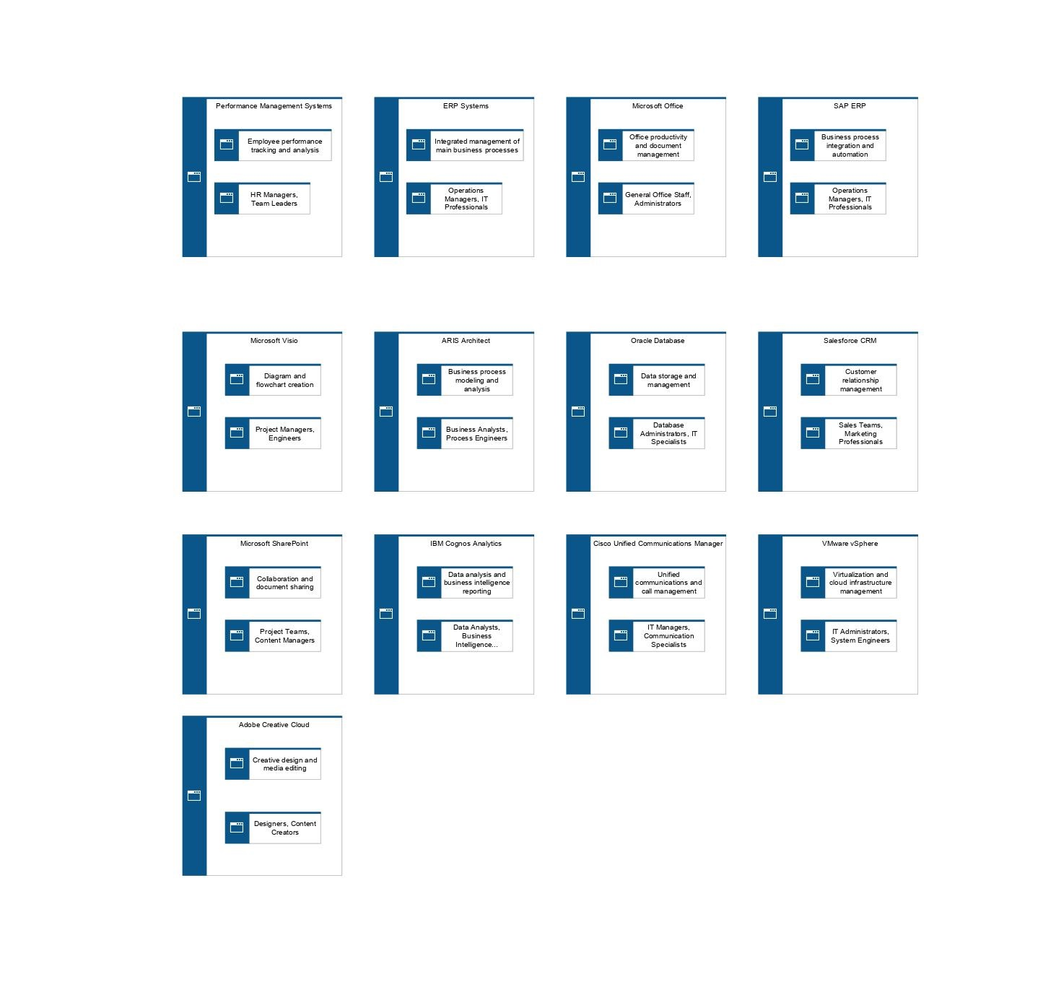

Description:

In Exercise 5, the task was to expand an existing IT infrastructure Application System Type Diagram by incorporating nested objects to provide more detailed information.

* We started by creating a new diagram within the IT Systems section of the UMG database to visualize the IT infrastructure.
* We opened a Word document listing applications, copied the list, and pasted it as objects into the ARIS model to ensure the model reflects the actual applications used by UMG.
* We modified the pasted objects by nesting them, mirroring the illustration provided. This meant placing smaller objects within larger 'category' objects to show the hierarchy and relationships between different systems.
* The 'outer' objects were resized to encompass the nested 'inner' objects properly, and we labeled each according to the type of IT systems they represented, following the structure given in the illustration.
* The final step was to save and close the updated model.

The purpose of this exercise was to deepen our understanding of the ARIS tool's functionality for detailing IT infrastructure. Nested objects in the diagram serve to clarify how different applications relate to each other and to the overall IT environment, which is essential for managing the IT landscape effectively.

**Exercise 6 – Occurrence and Definition Level**

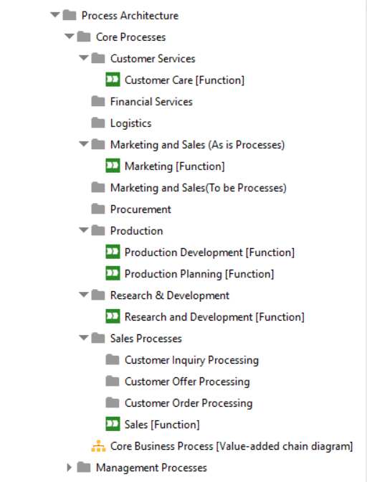

Description:

We organized the ARIS database content by distinguishing between model occurrences and object definitions.

* We moved the "Core Business Processes" VACD model to the "Core Processes" group within the ARIS Explorer to align with the database's logical structure.
* We identified where the object definitions for individual core business processes should be stored within the ARIS Explorer structure.
* We relocated the object definitions of "Research and Development", "Sales", "Production Development", and "Production Planning" to their corresponding groups within the ARIS Explorer.

The purpose of this exercise was to ensure that the database is logically structured for easy navigation and management, reflecting the importance of organization in database systems. This also aids in access control, as ARIS issues privileges based on groupings within the Explorer. The process is aligned with the need for clarity, maintainability, and effective database administration.

Exercise 7 – Create Occurrence Copy / Organizational

Responsibility in VACD

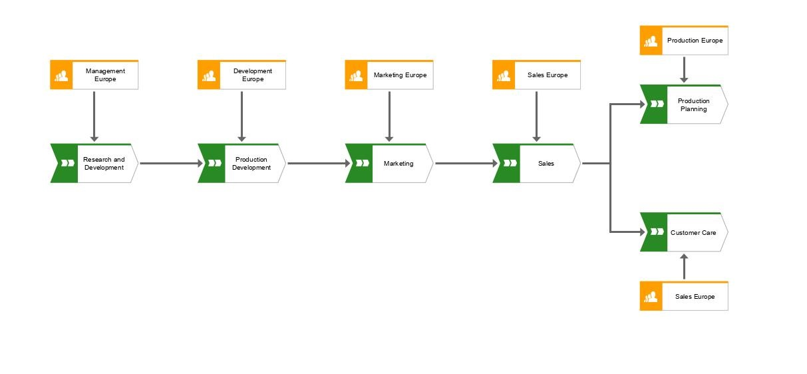

Description:

we added organizational responsibility to the VACD of Direct Car Sales previously created, using occurrence copies to map organizational units to their respective processes:

* Opened the Core Business Processes VACD and located within the ARIS Explorer under the "Core Processes" group.
* Integrated Organizational Responsibilities by utilizing occurrence copies of organizational units from the "UMG Organizational Chart Europe" to represent which units are responsible for specific processes in the VACD.
* Assigned Responsibilities:

1. Management Europe was linked to carrying out Research and Development.
2. Development Europe was responsible for Production Development.
3. Marketing Europe was tasked with Marketing.
4. Sales Europe was assigned to both Customer Care and Sales.
5. Production Europe was responsible for Production Planning.
6. Navigated to the Organizational Chart: We used the Properties -> Occurrences feature to link directly to the UMG Organizational Chart Europe, ensuring that the model reflects the actual organizational structure.

* Ensured that all models and changes were saved.

The exercise taught us the importance of accurately representing organizational responsibilities within process models, which is vital for clarity and accountability. Occurrence copies were used to avoid redundancy and maintain a single source of truth within the ARIS database, essential for effective process management and evaluation.

Exercise 8 – Incorrectly Event-driven Process Chain (EPC)

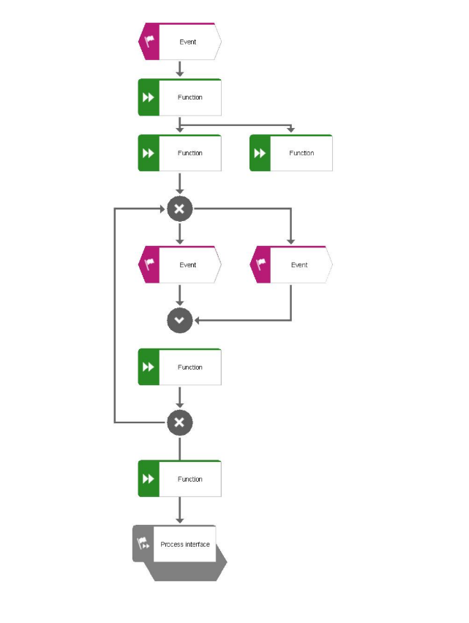

Answer:

1. There is a direct connection from an event to two functions without an intermediate event between the functions. Each function should be followed by an event in an EPC diagram.
2. After the XOR (exclusive OR) split, there is an event that does not immediately lead to a function. In EPC, an event should be followed by a function.
3. There is a direct connection between two functions without an intermediate event. This violates the rule that events and functions should alternate.
4. There are two events directly connected without an intervening function, which is not allowed in EPC diagrams.
5. The XOR connector is used incorrectly as it connects to an event and not a function on one path.
6. The diagram does not clearly define the starting event or the end event.
7. There is a function that directly leads to two events using an XOR connector. Each function should lead to one event which then decides the path using a connector.
8. The process interface is connected directly to a function through a connector without an intermediate event.
9. There is an XOR connector used just before the process interface, which should not be the case. A process interface typically follows an event, not a connector.

Description:

we analyzed an Event-driven Process Chain (EPC) diagram that was modeled incorrectly and identified the violations of EPC modeling rules:

* We examined each element of the EPC to determine if it followed the correct modeling syntax and semantics.
* We pointed out nine mistakes in the diagram that broke the EPC modeling rules. These errors included improper connections (like direct connections between events without a function in between), incorrect use of connectors (like an XOR used incorrectly), and missing elements (like the start and end events not being defined).
* The exercise helped us to better understand how EPCs should be correctly modeled, which is essential for accurate process representation and analysis.

The exercise emphasized the importance of adhering to modeling conventions for clarity and correctness in process documentation using the ARIS tool. It showcased the significance of alternation between events and functions, proper use of connectors, and the need for clear start and end points in process models.